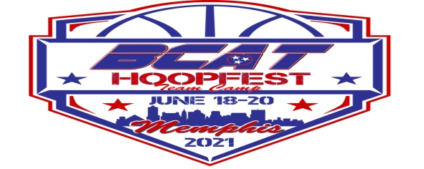
BCAT HOOPFEST Hotels

These are the hotels we have currently working with. Please ask for the BCAT rate.

Holiday Inn & Suites- Wolfchase Galleria
$119+tax per room up to 4 people and includes breakfast
2751 New Brunswick Road Memphis, TN 38133
Tel: 901.266.1952 | Fax: 901.266.1011 | Direct: 901.334.4864

ttps://www.holidayinn.com/redirect?path=hd&brandCode=HI&localeCode=en&regionCode=1&hotelCode=MEMWG&_PMID=99801505&GPC=BCA&cn=no&viewfullsite=true

Best Western Plus Galleria Inn & Suites $82+tax and includes Breakfast
Address: 8635 US-64, Memphis, TN 38133
Phone: (901) 372-0000

https://www.bestwestern.com/en_US/book/hotel-rooms.43162.html?groupId=I67JX8N6

Super 8 Lakeland $59.99+tax – 65.00 +tax
9779 Huff N Puff Rd, Lakeland, TN 38002
901-372-4575

Econolodge- Lakeland $70+tax
9822 Huff N Puff Rd, Lakeland, TN 38002
901-388-7120

Microtel Inn $85 Includes Breakfast
2423 N Germantown Parkway
901-213-4141
Quality Inn $94 Includes Breakfast
8166 Varnavas Dr
901-386-4600
Comfort Inn- $119 Includes Breakfast Rooms Sleep 5
2427 N Germantown Parkway
901-213-3600
Country Inn and Suites $111 Includes Breakfast
2270 N Germantown Pkwy
901-386-3600

